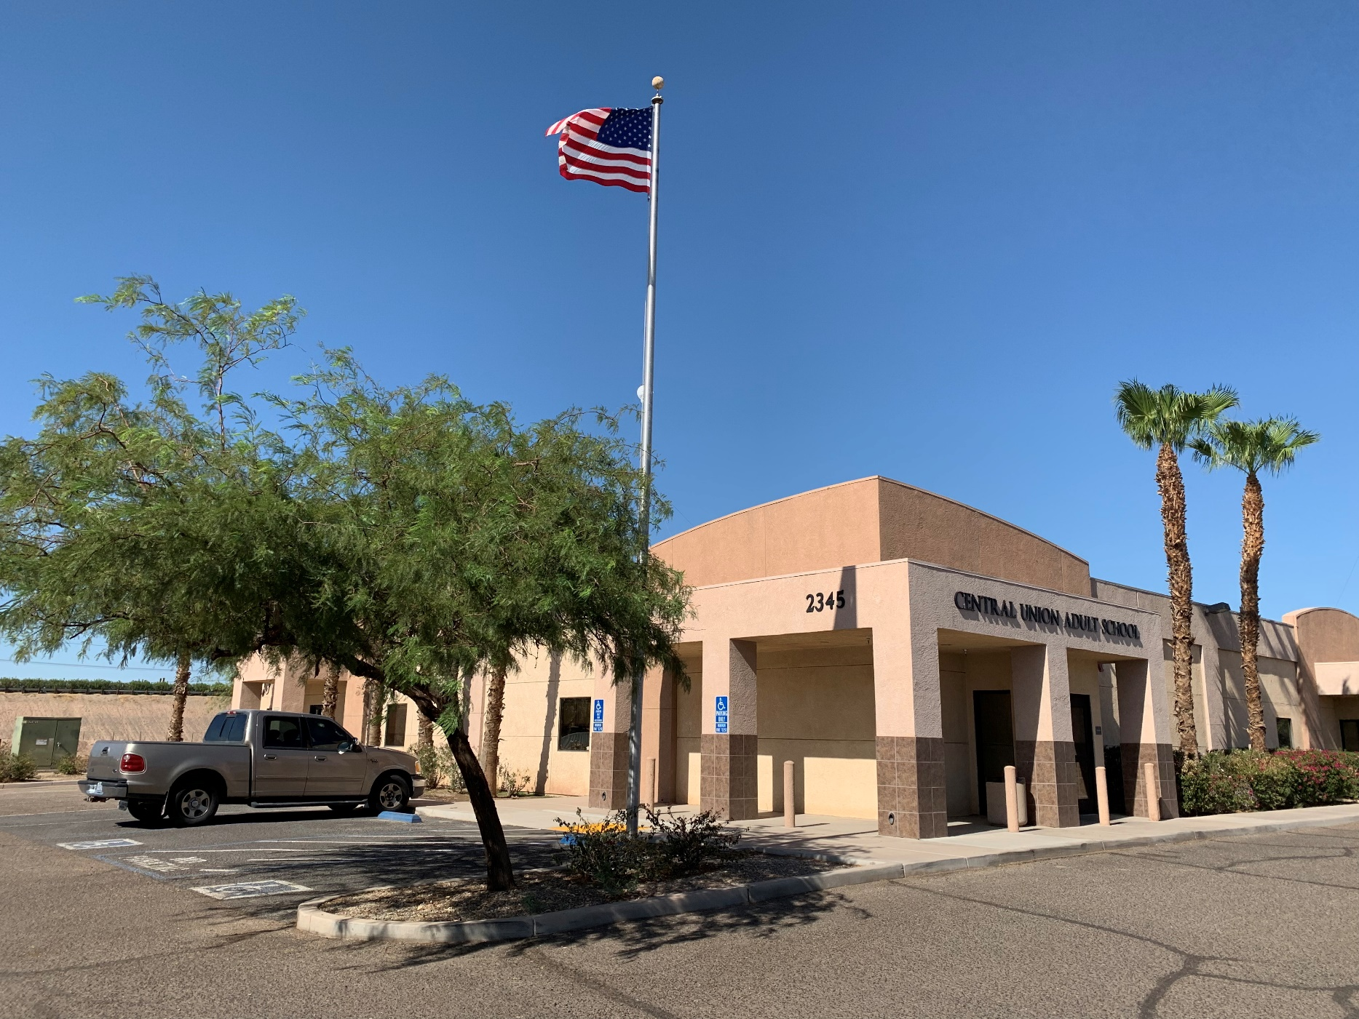

|  |
| --- |
| School Hours  2020-2021 |
|  |
|  |

Due to COVID-19 restrictions, our school has instituted Distance Learning for all classes. Our hours are:

OFFICE:

Open Office – 8:00-12:00 M-F

By Appt Only - 12:00-4:30 M-F

TESTING:

By Appt. Only - 8:30-4:30 MTWF

Online Classes Available:

HS Diploma - 9-11:30 M-F

12:30-3 M-F

5:30-8 MF

ESL - 9-11:30 M-Th

12:30-3 M-Th

5:30-8 M-Th

5th Yr Seniors - 4-7 M-Th

Concurrent Enroll - 4-7 Tue

Logo

Description generated with very high confidence